JavaPOS Printer Driver
User Guide
for NCR Retail Printers


Issue A
The product described in this book is a licensed product of NCR Corporation.
NCR is a registered trademark of NCR Corporation.
It is the policy of NCR Corporation (NCR) to improve products as new technology, components, software, and firmware become available. NCR, therefore, reserves the right to change specifications without prior notice.
All features, functions, and operations described herein may not be marketed by NCR in all parts of the world. In some instances, photographs are of equipment prototypes. Therefore, before using this document, consult with your NCR representative or NCR office for information that is applicable and current.
To maintain the quality of our publications, we need your comments on the accuracy, clarity, organization, and value of this book.
Address correspondence to:
Manager, Information Products
NCR Corporation
2651 Satellite Blvd.
Duluth, GA 30096
Copyright © 2004
By NCR Corporation
Dayton, Ohio U.S.A.
All Rights Reserved

Preface
Audience
This guide is targeted to users who want to understand how NCR printer driver works in order to maximize the capabilities of the printer and print text/graphics documents successfully.
This guide is also geared toward software developers who need to create custom application to perform special printer functionalities using native printer command sequences such as barcode printing, bit-image download, bit-image printing, printer status notification, etc.
Notice: This document is NCR proprietary information and is not to be disclosed or reproduced without consent.
References

JavaPOS Home Page: http://www.javapos.com/

Table of Contents
Introduction 1
Printer driver Architecture 2
JavaPOS Overview 2
How JavaPOS works 3
NCR POS Application Programming Interface 4
Installation 6
Configuration jpos.xml 6
Configuration Instructions 6
Uninstallation Instructions 6
How to use JavaPOS 7
Installation Instructions 7
Administration - CUPS Web Interface 8
Overview 8
Requirements for using the JavaPOS 8

Revision Record
Issue | Date | Remarks
A | Apr 2014 | First issue

Introduction
This manual discusses the JavaPOS technology in order to successfully print on the following NCR Retail printers:
- NCR 7167 Receipt Printer
- NCR 7167 Slip Printer
- NCR 7197 Receipt Printer
- NCR K590 Self-Service Printer
- NCR 7168 Receipt 2ST Printer
- NCR 7168 Slip Printer

Printer driver Architecture

JavaPOS Overview
JavaPOS is a standard solution for POS printers based on Java technology.
This pattern allows the printer can print text and graphics without worrying about the communication hardware.

Para maiores informações, usar a documentação do JavaPOS

Figure 1. JavaPOS architectural diagram

How JavaPOS works
Sua aplicação irá se comunicar com o dispositivo de controle que é responsável por realizar todo o tratamento e controle das chamadas realizadas para o dispositivo.
O dispositivo de controle chama o dispositivo de serviço que é o responsável por se comunicar e gerenciar diretamente o dispositivo físico (ou lógico).
Ao abrir a conexão com a impressora, o JavaPOS retorna todos os status atuais da impressora(sem papel, tampa aberta, etc).
Para cada modelo de impressora existe uma configuração para o tipo de conexão e características da impressora.
Toda a configuração é realizada dentro do arquivo jpos.xml, neste arquivo tem a informação do modelo da impressora, tipo de conexão, configuração de conexão, e configuração de impressora 2ST.
Modelos de impressoras suportadas e seus respectivos arquivos de configuração:
Impressora 7167 - com.ncr.jpos.services.ptr.models.Printer7167
Impressora 7168 - com.ncr.jpos.services.ptr.models.Printer7168
Impressora 7197 - com.ncr.jpos.services.ptr.models.Printer7197
Impressora 7198 - com.ncr.jpos.services.ptr.models.Printer7198
Impressora K590 - com.ncr.jpos.services.ptr.models.PrinterK590

The first time you print to a printer, CUPS creates a queue to keep track of the current status of the printer (everything OK, out of paper, etc.) and any pages you have printed.
Every time you print something, CUPS creates a job which contains the queue you are sending the print to, the name of the document you are printing, and the page descriptions. Job are numbered (queue-1, queue-2, and so forth) so you can monitor the job as it is printed or cancel it if you see a mistake.
When the print job is completely printed, CUPS removes the job from the queue and moves on to any other jobs you have submitted. You can also be notified when the job is finished, or if there are any errors during printing, in several different ways.

NCR POS Application Programming Interface
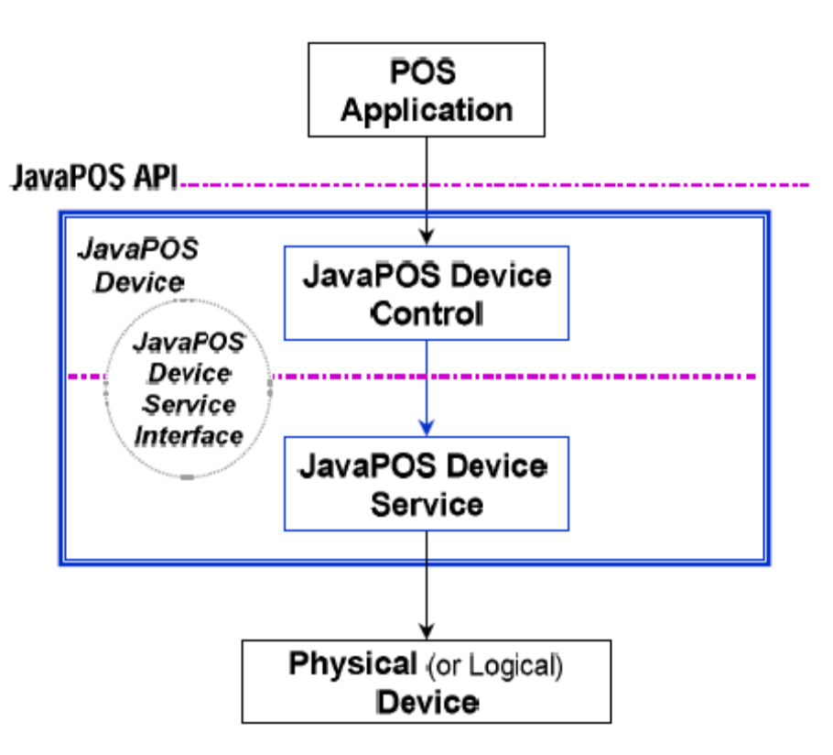Aside from printing normal text/graphics documents, NCR printers are capable of reporting printer status and performing special printer functionalities using native printer command sequences such as barcode printing, bit image download and printing, etc. To take advantage of these functionalities, NCR provides NCRPOSAPI.so which application developers can exploit. This lib will be part of the NCR POS printer driver installation package. It is copied during installation to the System directory of the OS.
NCR POS API exports the following functions:
- NCRPOS_WritePrinter()
- NCRPOS_ReadPrinter()
- NCRPOS_PrinterStatus()
The application developers will load this SO using a NCRPOSAPI header file which is available in /usr/includes/ and linking the project with libNCRPOSAPI.so available in /usr/libs/
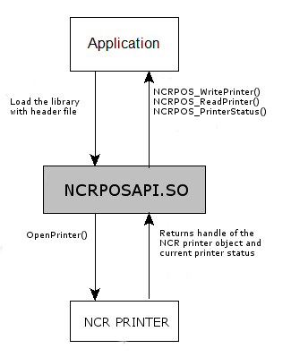
Figure 2. Architecture of Interfacing with an application module

Installation
Before installing the NCR drivers, close all applications and TSR (Terminate and Stay Resident) programs that load at such as virus checkers, fax utilities, etc., and all other applications that may be open, also close all shell utilities.

Configuration jpos.xml

Configuration Instructions
- Open a file jpos.xml

<?xml version="1.0" encoding="UTF-8"?>

<!DOCTYPE JposEntries PUBLIC "-//JavaPOS//DTD//EN" "jpos/res/jcl.dtd">
<JposEntries>
<JposEntry logicalName="defaultPOSPrinter">
<creation factoryClass="com.ncr.jpos.services.ptr.NCRInstanceFactory"
serviceClass="com.ncr.jpos.services.ptr.models.Printer7168" />

How to use JavaPOS

Installation Instructions
- Double click on NCR POS-PRINTER-DRIVER-1.0-1.fc15.i386.rpm package and click Install button.
- Type the password Administrator (root) and then click Authenticate button.

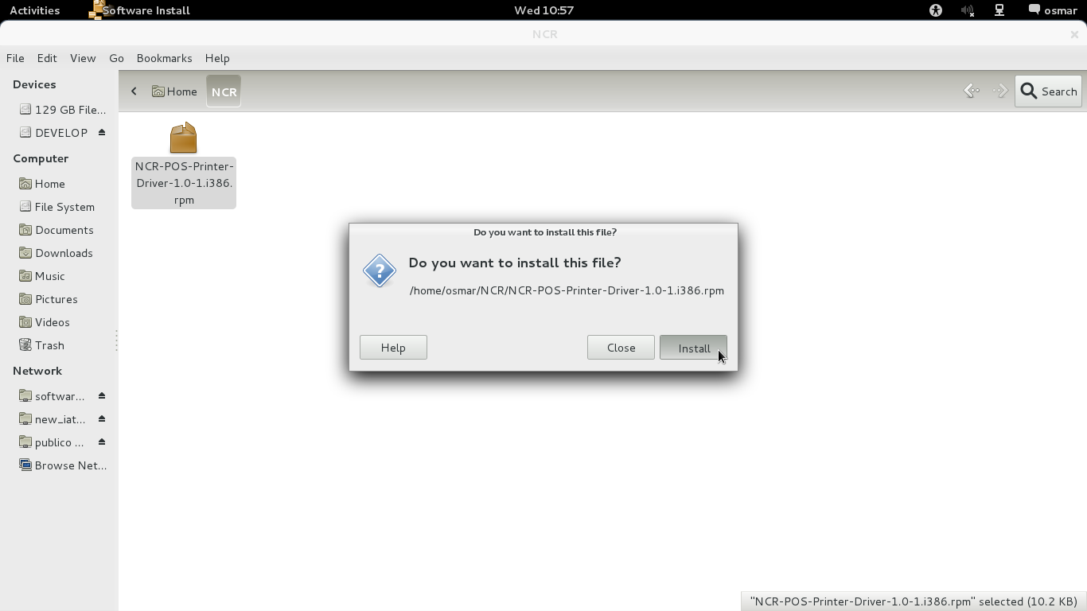
Figure 3. Installation NCR package

Requirements for using the JavaPOS

Overview

Required JavaPOS packages include the following:
- NCRPosPrinterDevice.jar
- libs
- jpos113.jar
- jpos113-controls.jar
- log4j-1.2.17.jar
- RXTXcomm.jar
- Log4j.properties

JavaPOS Printer Driver
User Guide
for NCR Retail Printers

